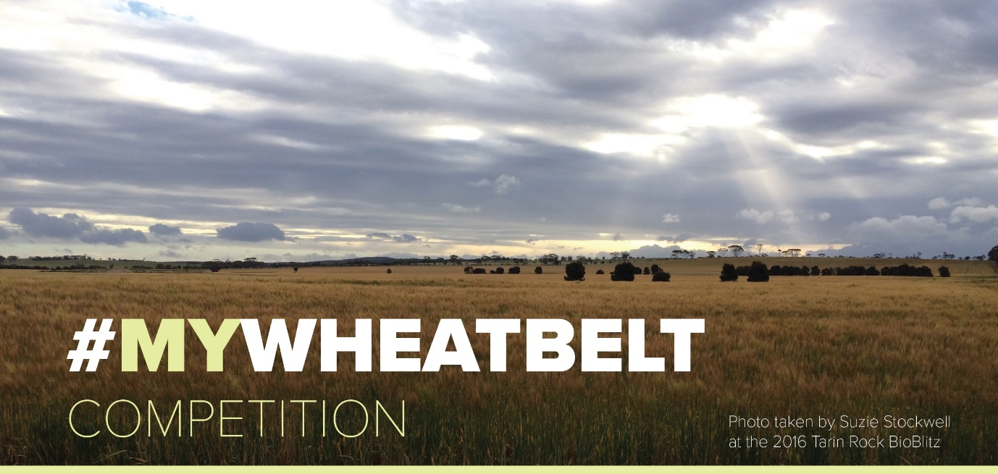
Parent/Guardian Permission to enter
the #MYWHEATBELT Competition
NAME (please print)
AGE
DATE
SIGNATURE
PARENT/GUARDIAN NAME (please print)

DATE
PARENT/GUARDIAN SIGNATURE

